PYTHON MINI PROJECT

# GAME OF TANKS

PROJECT MADE BY :-  
 1. Prithviraj Patil - 501850 2. Pranav Patil - 501849 3. Arnav Pandey - 501847

# INTRODUCTION :-

In this python mini project , We have created a simple application of python Sockets and Pygame Library.

In this project we can play a multiplayer game with other players in our local network. Players will have their own tanks and some particular number of bullets. Players have to destroy opponents tank to win the game. Some amount of health will be decreased when tank gets hit by a bullet. When the health became zero tank will be destroyed and Result will be provided on the screen.

# TECHNOLOGY STACK :-

* Python
* Pygame and Sockets libraries

# DESIGN :-

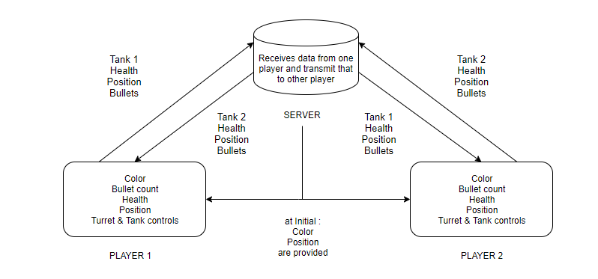

# HOW TO RUN :-

Let Computer 1 be the server and Computer 2 and 3 be players. All three are in the same network.  
In Computer 1 store server.py and network.py in the computer1 and name that folder as Server.  
In Computer 2 and 3 store player.py, rmain.py and all wav files and name that folder as Player.  
Open command prompt of computer 1 and write command to find ipv4 address .  
 command :- “ipconfig”  
Change server=”192.168.43.33” to server=”IPV4” address in file server.py and network.py  
Then in computer 1 open terminal at Server file and write command as following :-  
 command :- “python server.py”  
Open terminal at computer 2 and 3 at file location Player and write command as following:-  
 command :- “python main.py”

# OUTPUT :-

* PLAYER SCREEN AT INITIAL STAGE :-

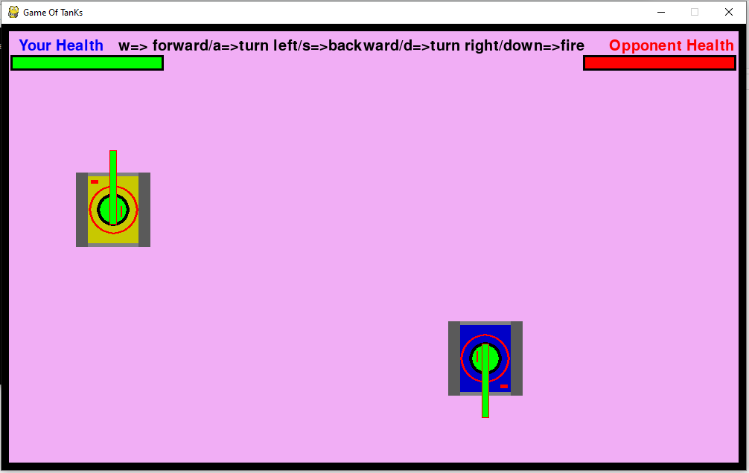

* PLAYER 1 SCREEN

Shooting bullet towards opponent

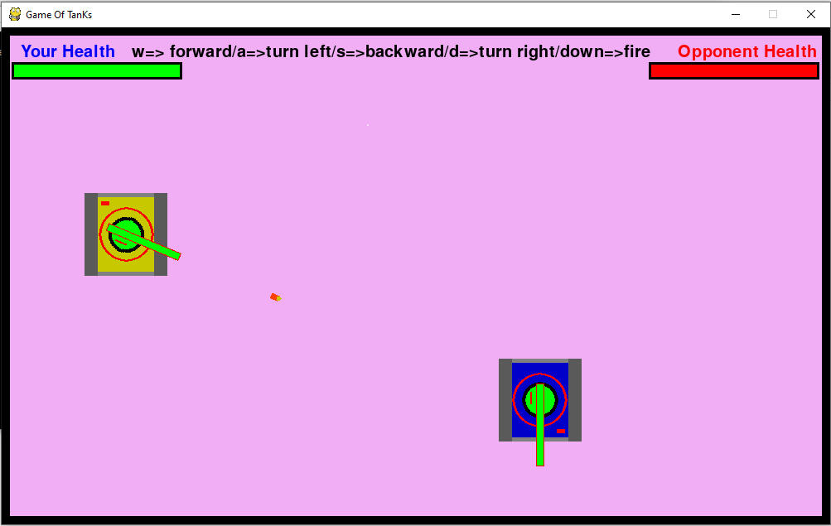

* PLAYER 1 SCREEN

Opponent Got hit by Player 1 bullet and his health decreased

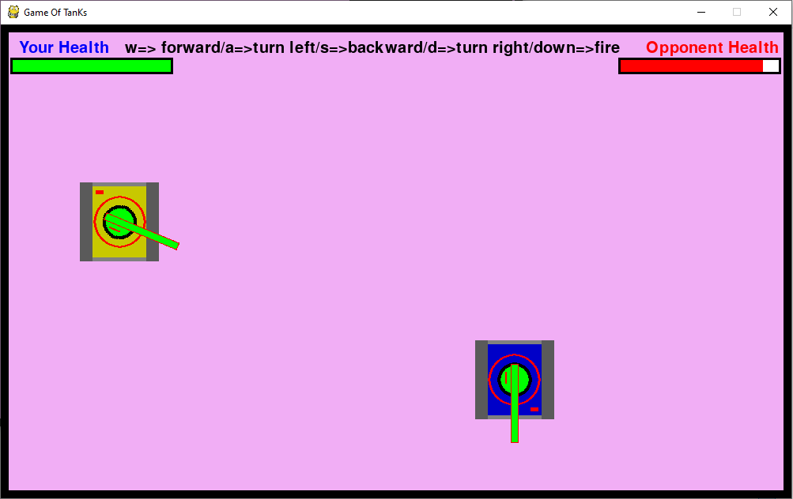

* PLAYER 2 SCREEN

Player 2 got hit by player1 bullet and his health is decreased

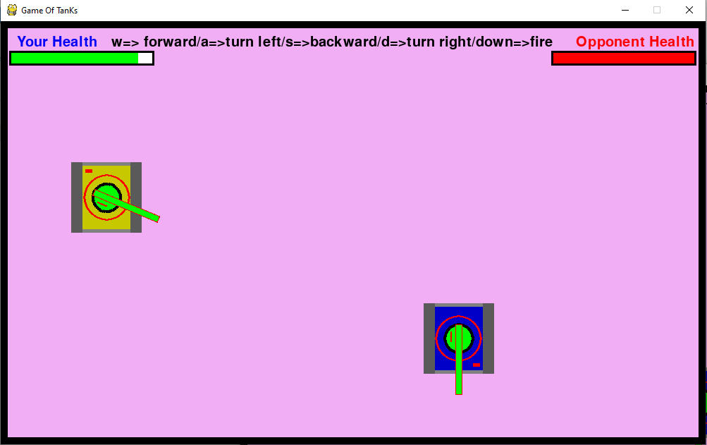

* PLAYER 2 SCREEN

Player 2 hit bullet towards player 1

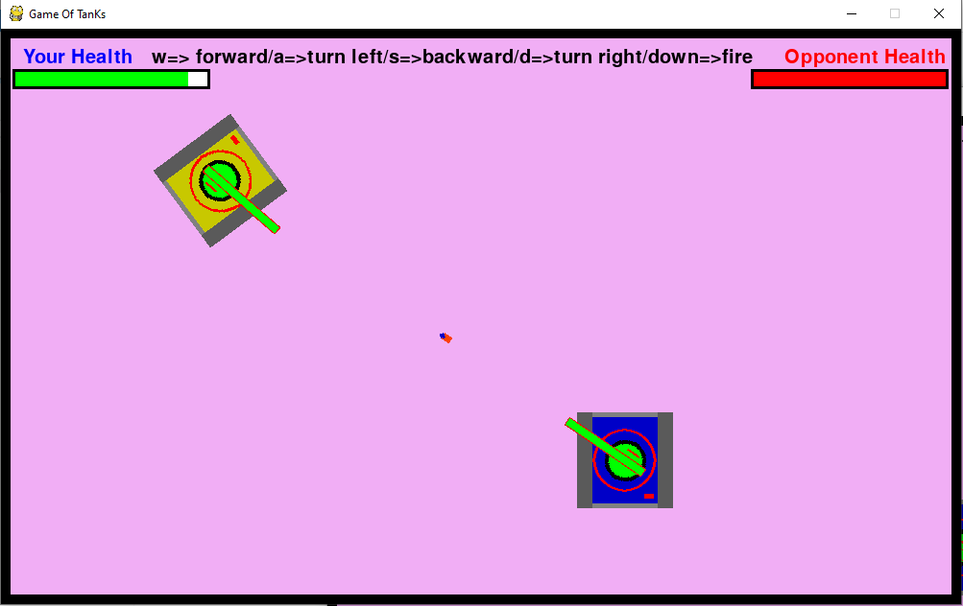

* AFTER WINNING

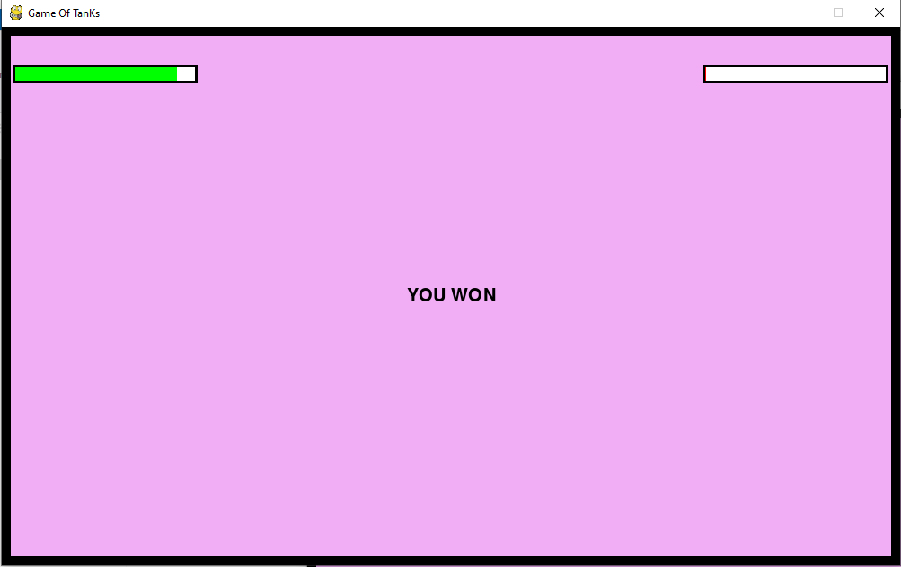

* AFTER LOOSING

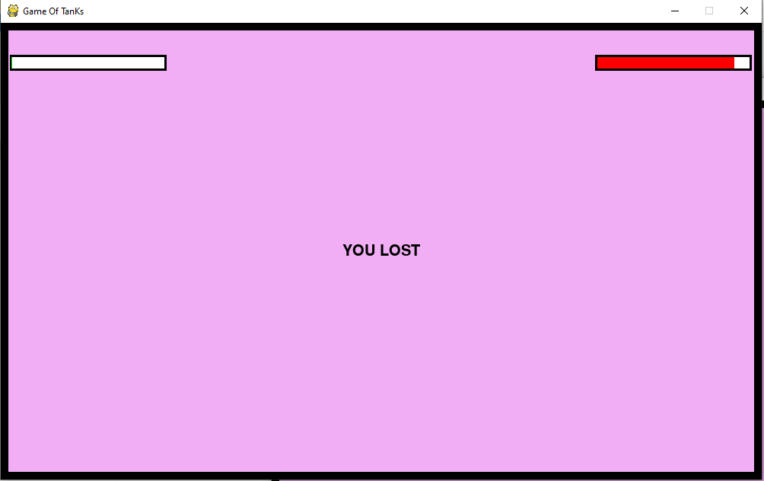

# REFERENCES :-

1. Pygame.org
2. SocketProgramming.org
3. Thepythongamebook.com
4. GeeksForGeeks.org